Keylogger Project using Python

Let’s create a new project directory named keylogger_project.

To make a new directory, type the following command

mkdir keylogger_project

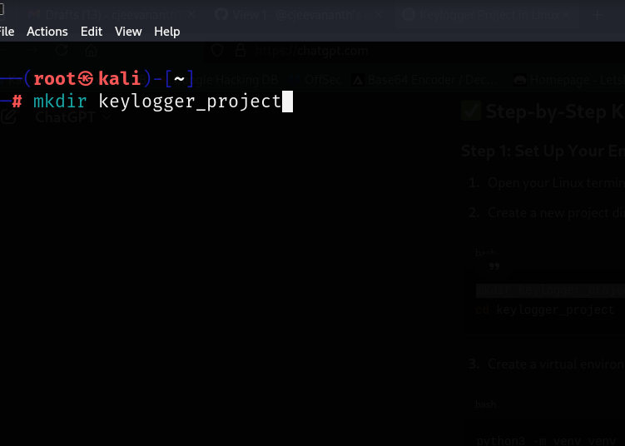

Now, let’s open the directory using the command

**cd keylogger_project**

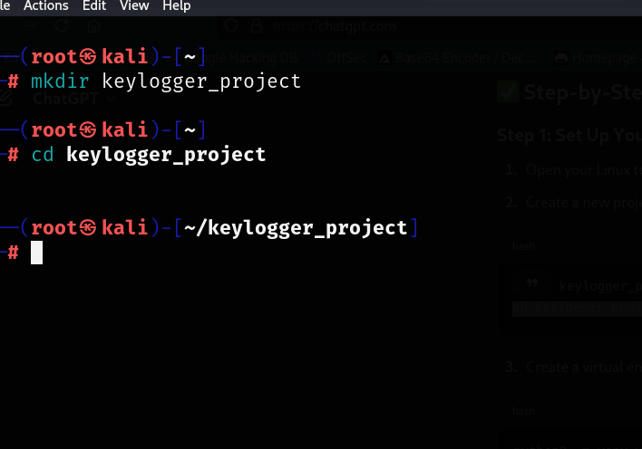

Now, let’s create a virtual environment and this is optional but recommended. This is used to test everything safer in virtual environment. So when we install pynput inside venv and we closed it; we need to reinstall it everytime when we use virtual environment unless it is installed globally in the system.

Type in the command

python3 -m venv venv

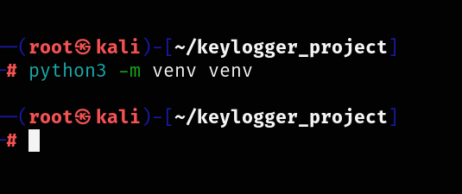

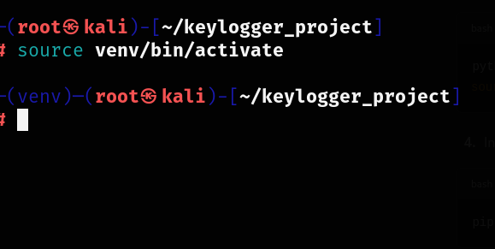

Install the required package pynput

(pynput is a Python library that makes it incredibly easy to control and monitor input devices such as your mouse and keyboard. With pynput, you can press keys on your keyboard, or move your mouse, all from your Python program.)

pip install pynput

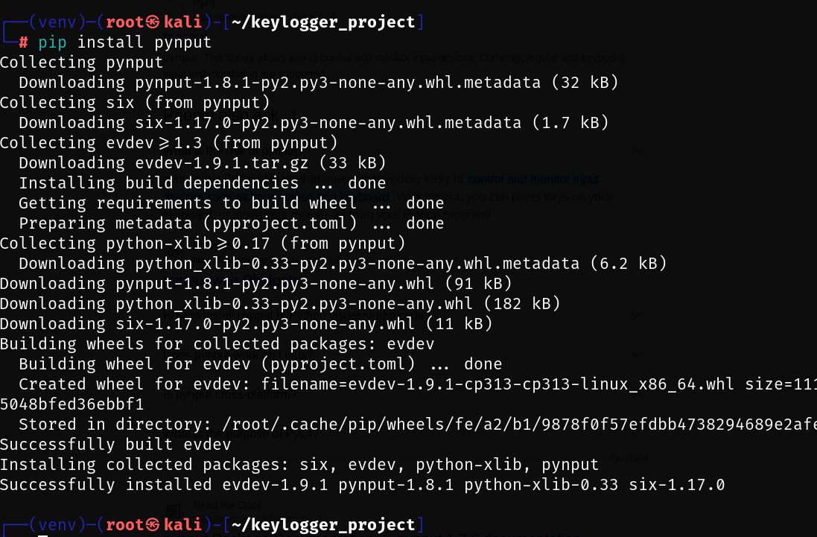

Now, let’s write a basic keylogger script.

Create a new Python file:

nano keylogger.py

Now, this will open the following nano text editor and let’s paste the advanced python script.

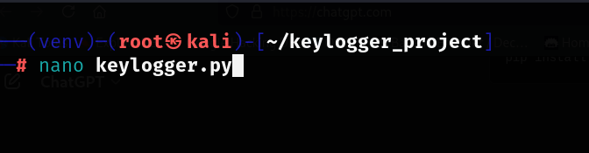

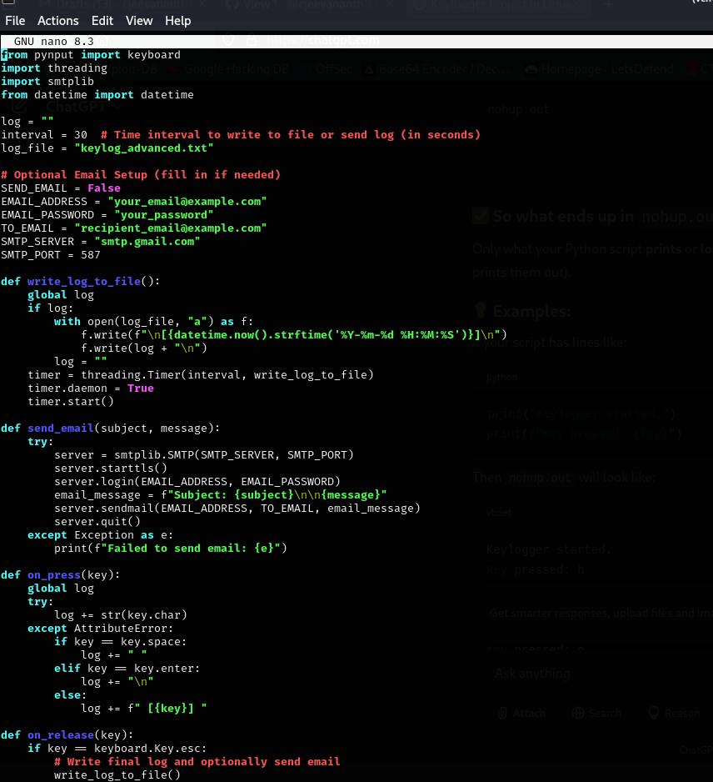

Now click on CTRL+X to save and exit the file. Let’s run the python file using the following command.

Now, let’s run the script

python3 keylogger.py

It starts to run and capture what you type and closes when you hit escape.

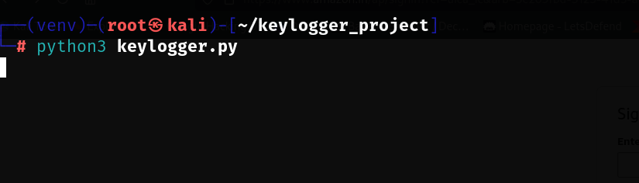

Now, type the username and password in any of the login page or whatever you type, it will be stored as a text file.

Now, press ESC to close the running keylogger.

Type ls command to see if the file is stored.

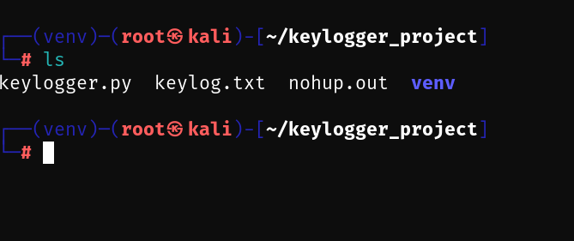

As we can see, the file has been stored.

Now, open the file using the cat command.

cat keylog.txt

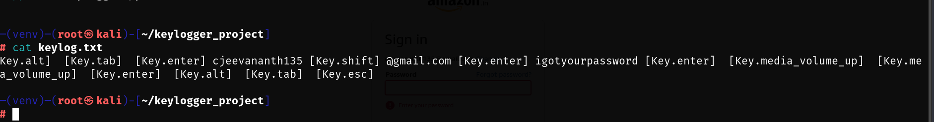

We can see the username and password, I have typed has been stored in the text file along with the keys, I have clicked that includes volume button, alt, enter etc.

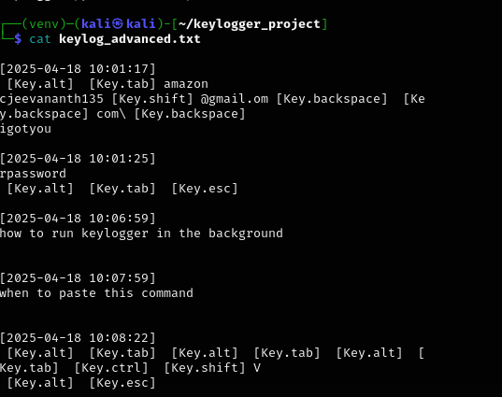

This result was derived as I’ve used advanced python scripting for keylogger.

It captures all the lines with the timestamps.